**NAME: CHANDRU.V**

**DEPT: CSE – C**

**REG.NO: 2127220501303**

**GIT-** [**https://github.com/chandru-26**](https://github.com/chandru-26)

**DATABASE CREATION -postgressSQL**

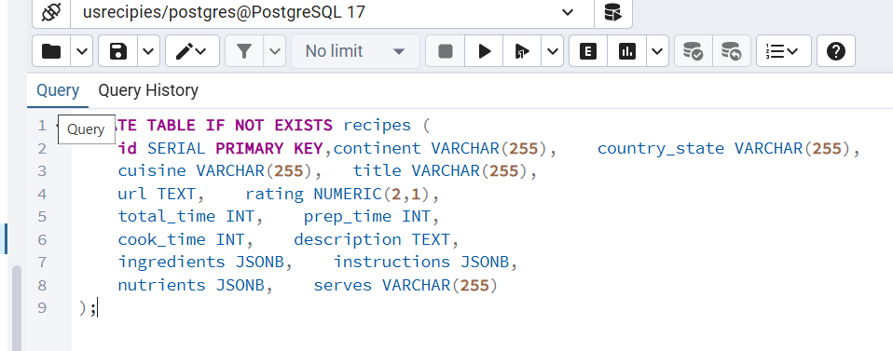

DB NAME –“**usrecipes**” with table name recipes

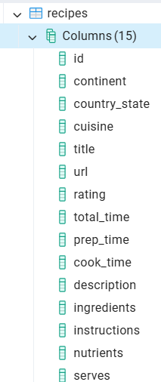

**Project creation**

Backend folder initialize-“npm init -y”

**Installing node modules**

* npm install pg
* npm install express
* npm install axios

creating main file”server.js”

**connection to database**

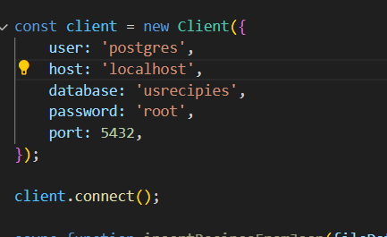

**Function to fetch data—insertRecipesFromJson**

Where the json is converted to utf8 encoded string and then it is given to a java object. For loop to fetch and insert each data to the database.

SQL injection is prevented by this method.

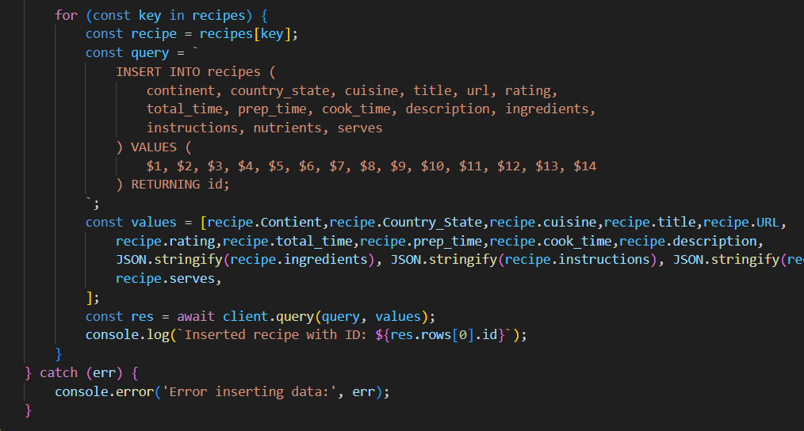

**API ENDPOINT creation:**

API-1 to return first 10 entries,

SELECT * FROM recipes LIMIT 10;

Route- <http://localhost:3000/api/users>

API-2 to display the top 10 highly rated entries

SELECT * FROM recipes WHERE rating IS NOT NULL ORDER BY rating DESC LIMIT 10;

Route- <http://localhost:3000/api/usersrating>

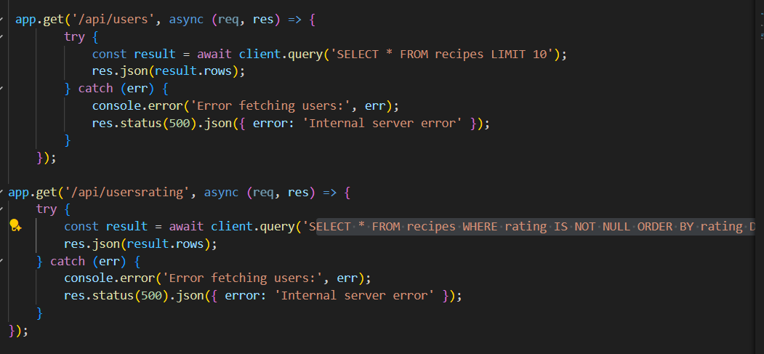

**OUTPUT**

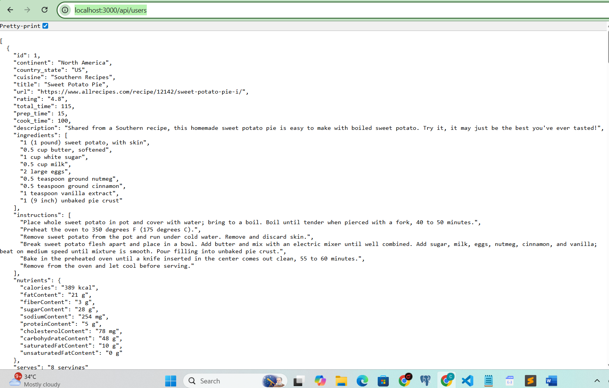

**TOTAL – 8451 ENTRIES**

**GIT REPO LINKT--** **https://github.com/chandru-26/securine**

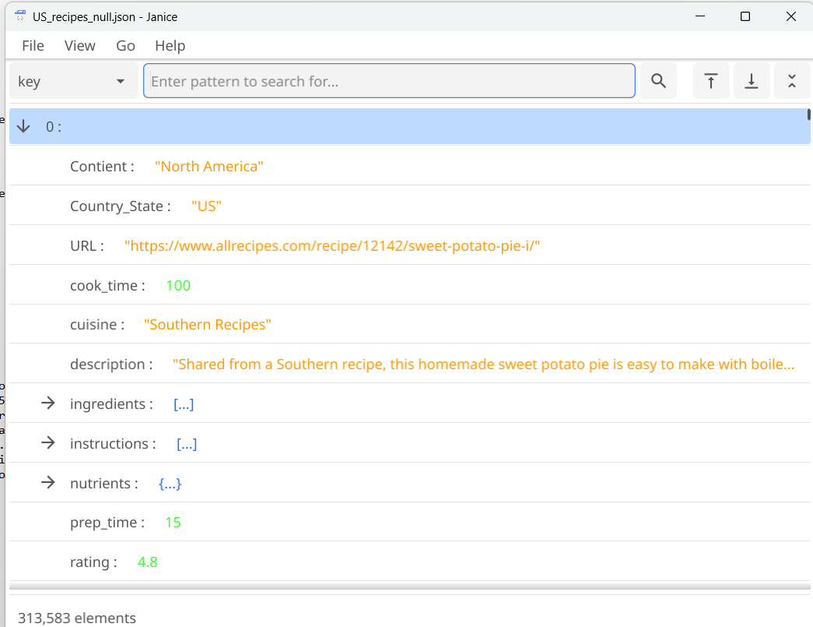

**FRONTEND- YET TO COMPLETE**

